Task on CloudTrail & CloudWatch

- Enable CloudTrail monitoring and store the events in S3 and CloudWatch log events.
Create cloud trail in that add s3 bucket and cloudwatch log group for store the logs
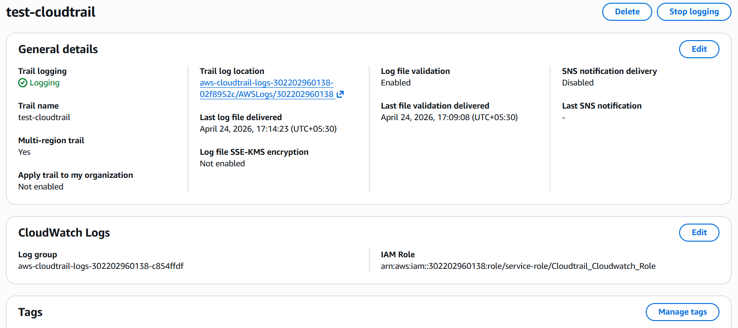
Create cloudwatch log group
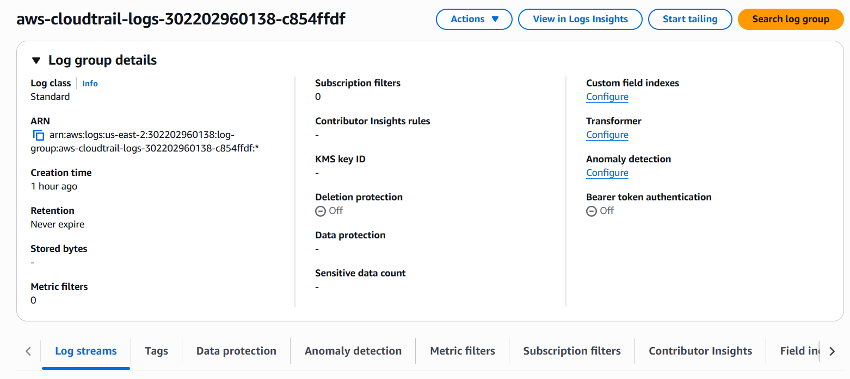

We can logs in S3 bucket
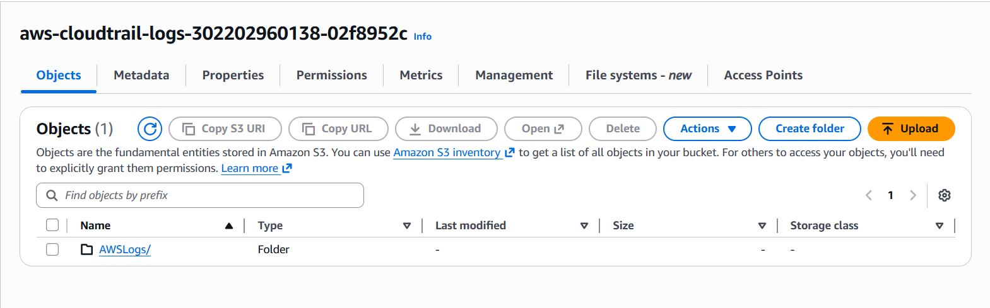
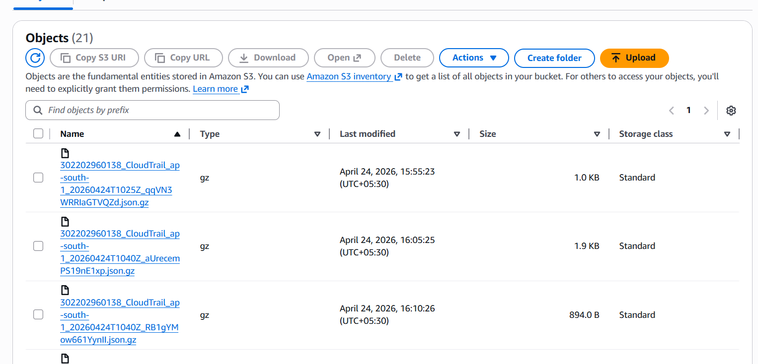
We can check logs in cloud watch log group log steams
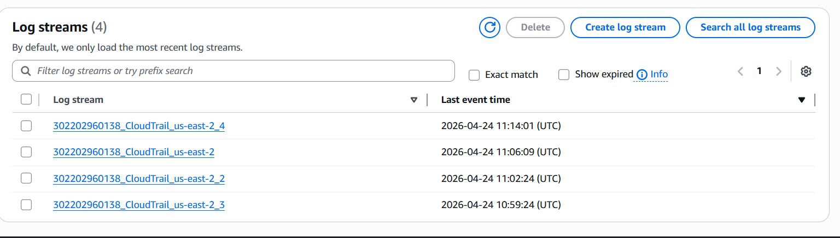

- Enable SNS for CloudTrail to send alerts via email.

Click to create SNS create a topic
Send the conformation mail to your gmail
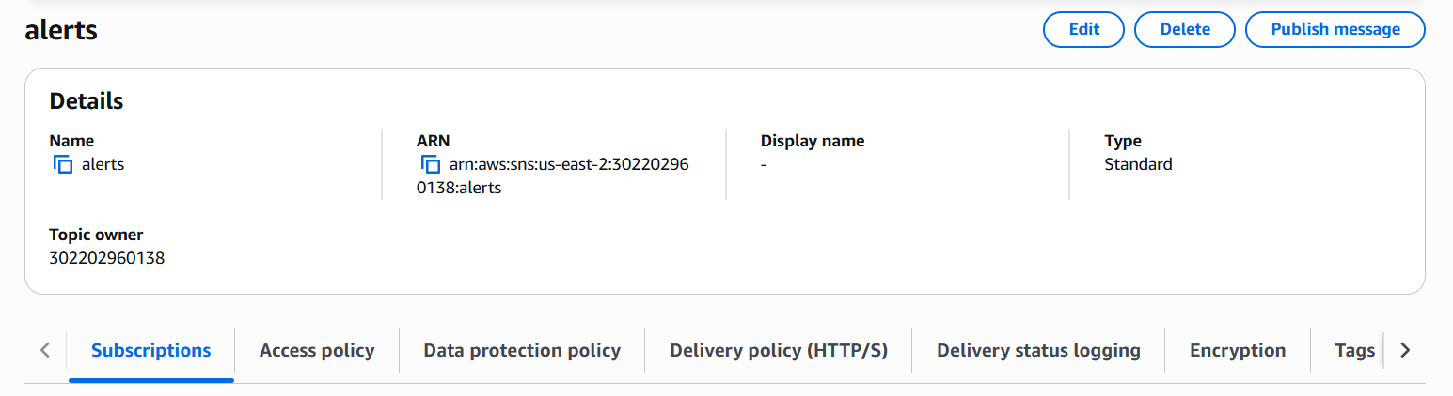
Accept the subscription
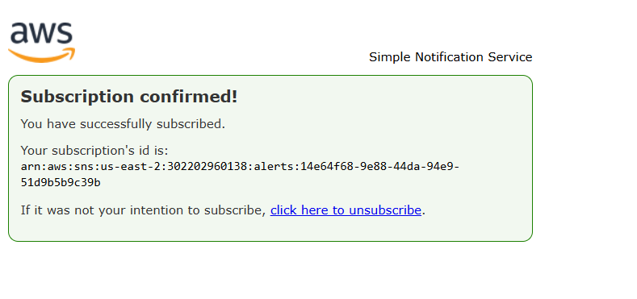
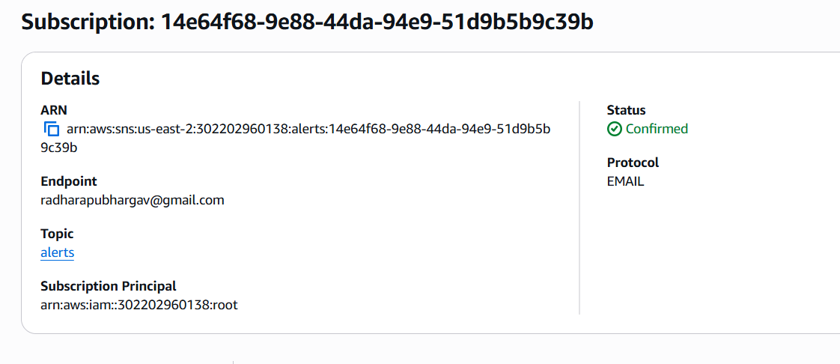
Enable the SNS in the cloud trail
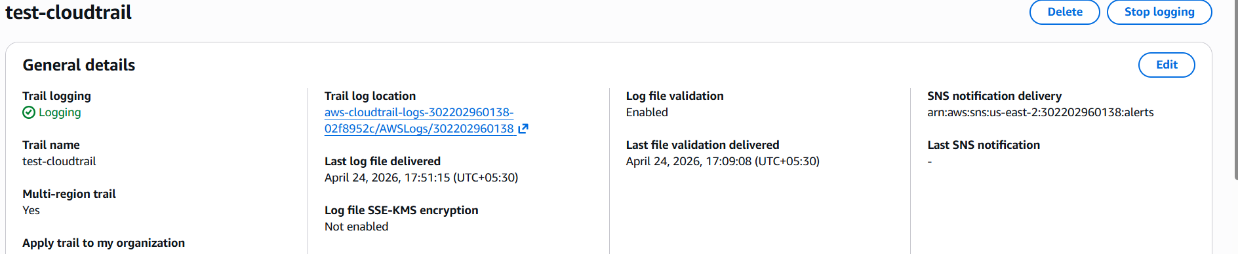
We can see the logs in our mail
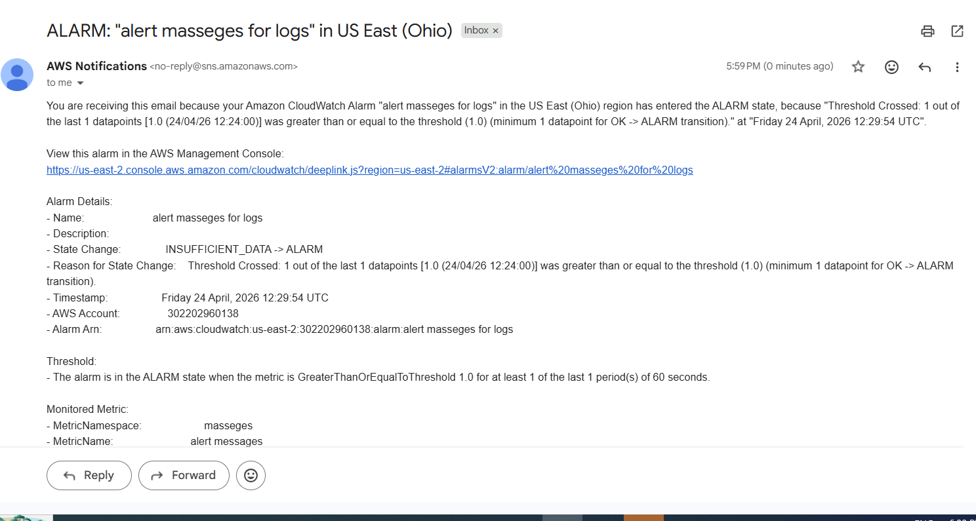

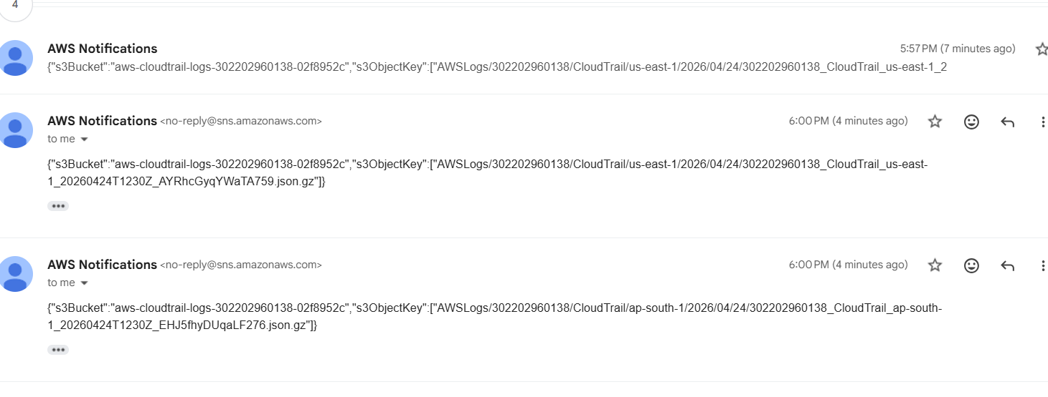
- Create a metric in the cloudwatch
- Create alarm for that metric
- Open mail and check the alert
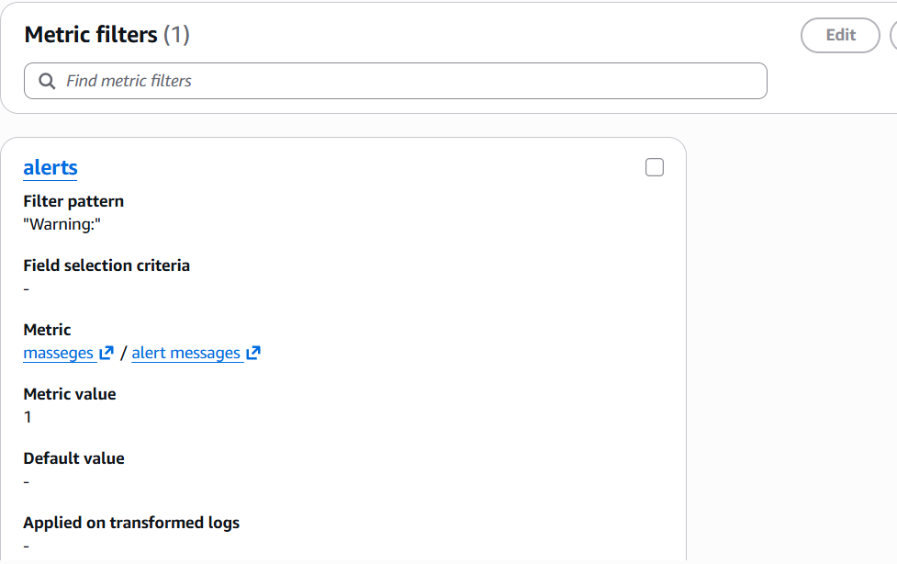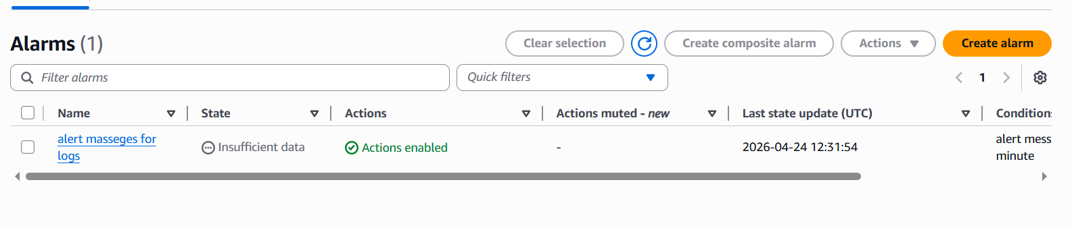

- Configure CloudWatch monitoring and record the CPU utilization and other metrics of EC2
Select the Ec2 instance
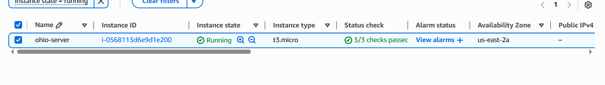

Click to instance setting — troubleshoot —- detailed monitoring : enable it
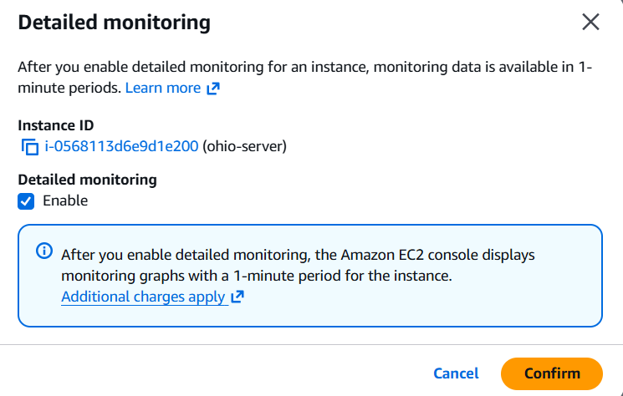
See the metrics of the instance here we can see the detailed monitor
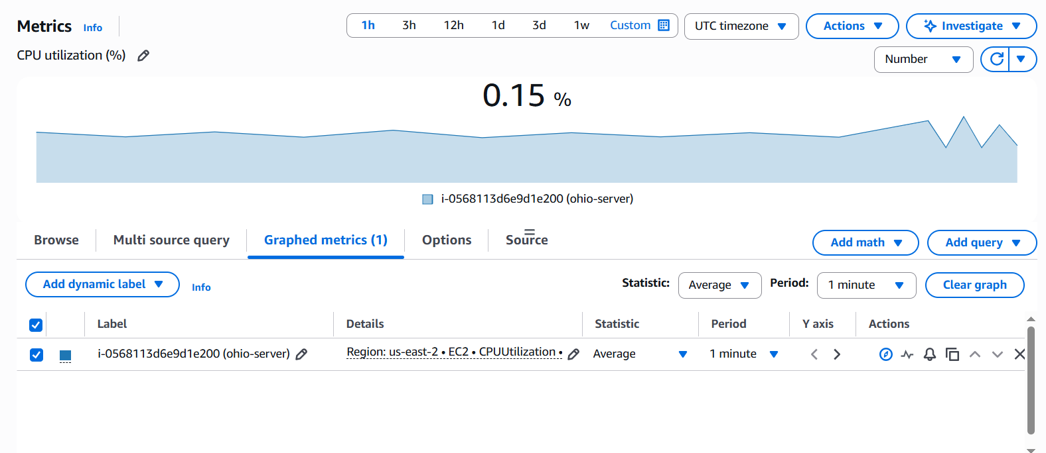

- Create one alarm to send an alert to email if the CPU utilization is more than 70 percent.

Create alarm — select metric—add metrics
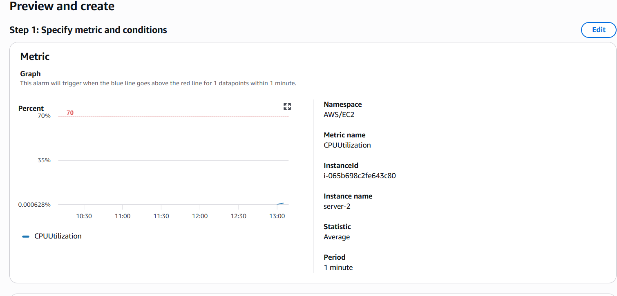
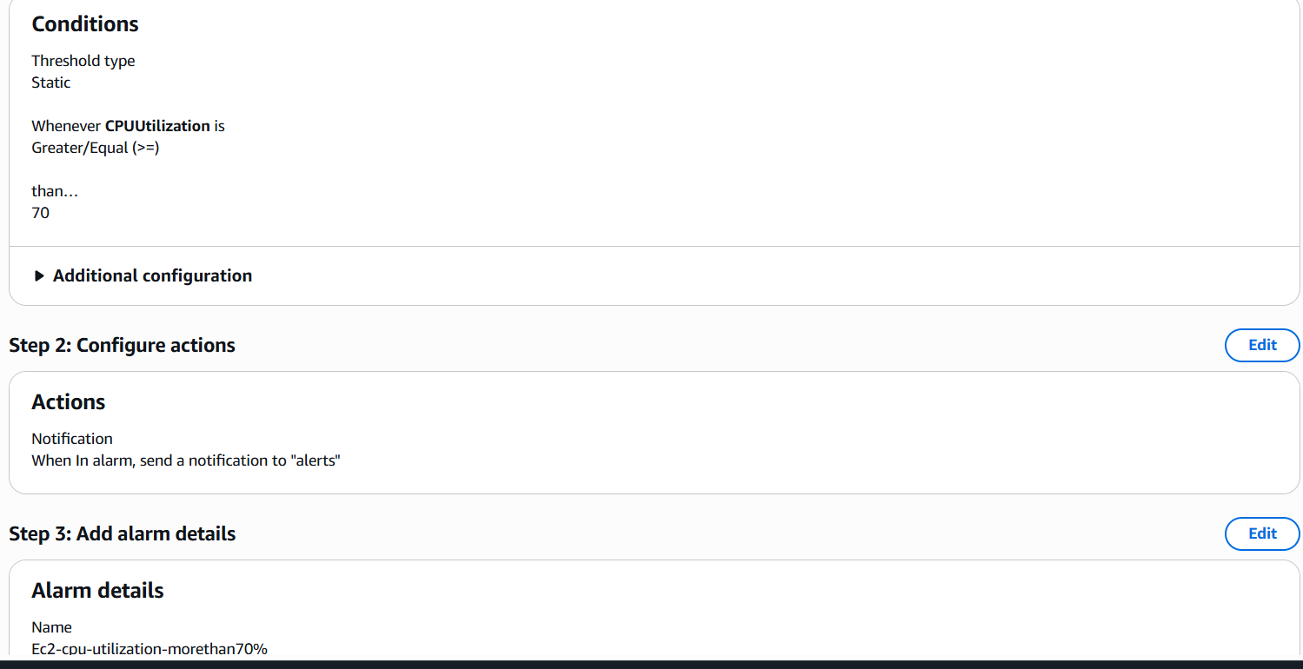

Here we can see the alarm OK stage

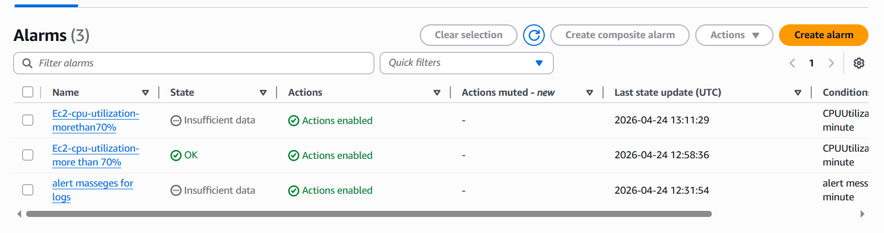
Our EC2 instance CPU utilization more than 70%, now it is alarm stage
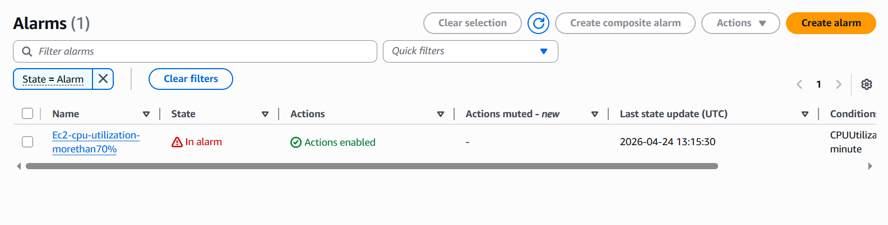
Now sent a mail like your CPU utilization more than 70%
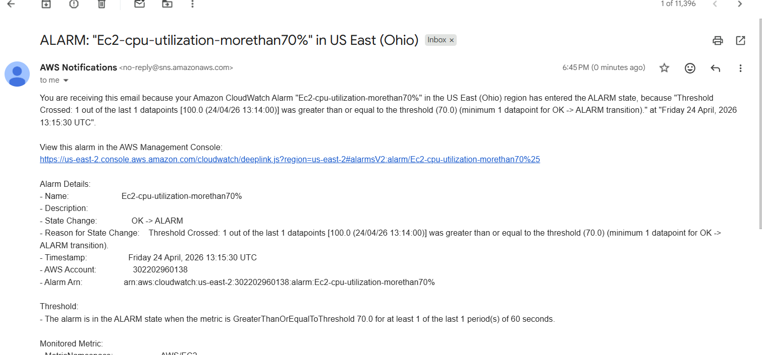

- Create a Dashboard and monitor the Tomcat service whether it is running or not and send the alert.
Install EC2 instance
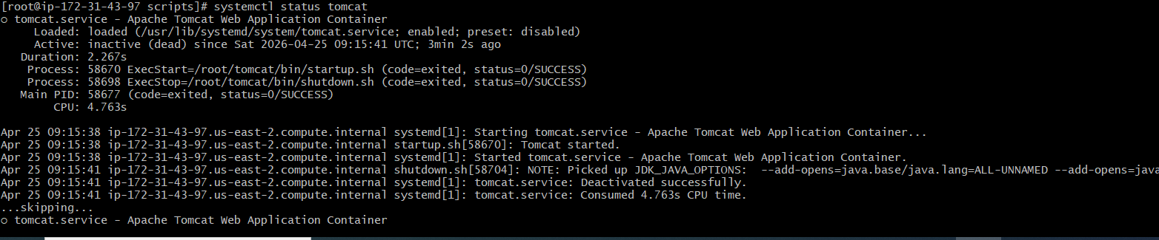
Start tomcat service
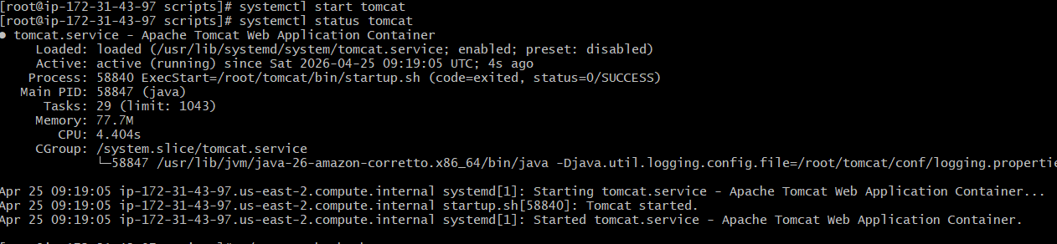
Create Tomcat Check Script :
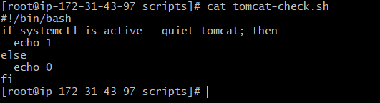

Configure AWS CLI
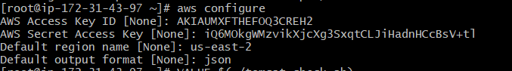

Add scripts for push metrics to cloud watch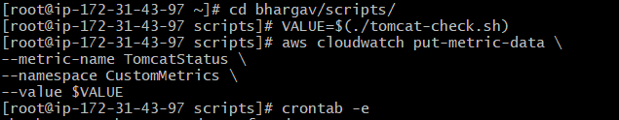
Check in the cloudwatch
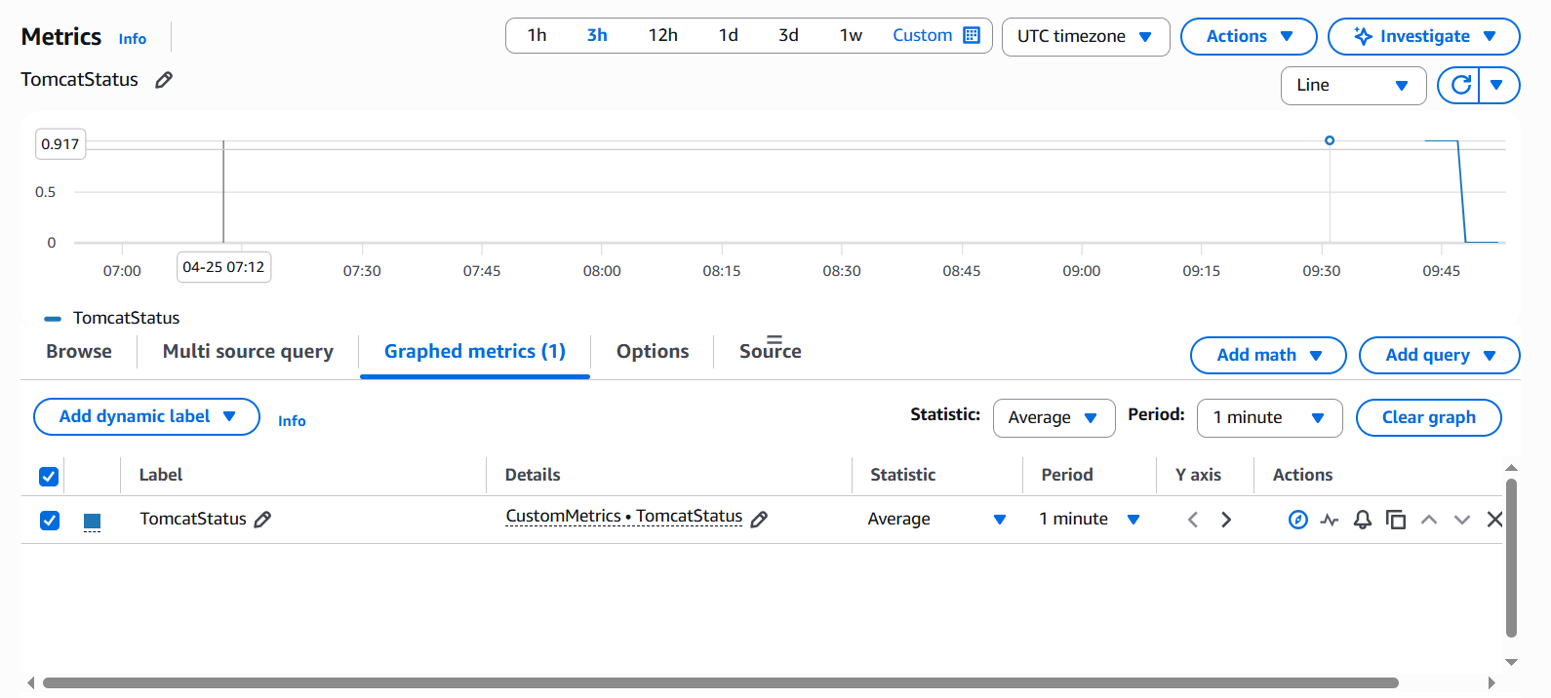

Stop the tomcat service and you get alarm

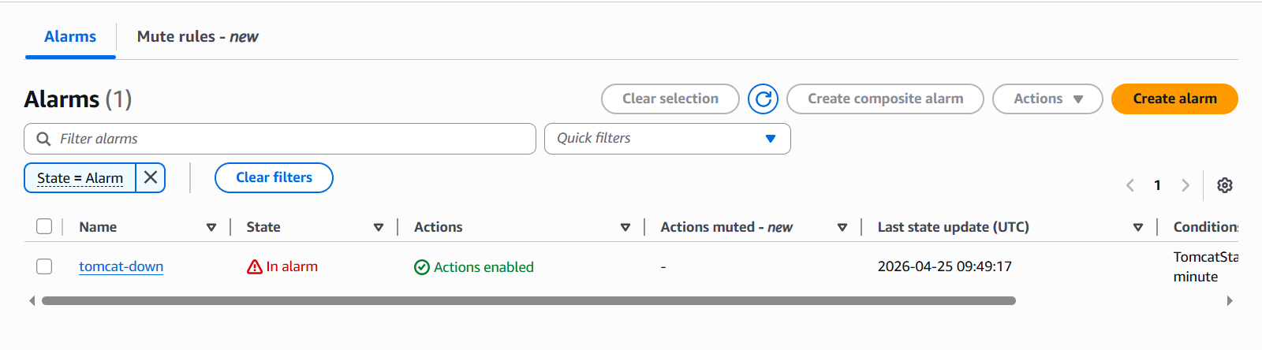

Check the metrics if it shows 0 your tomcat service is inactive
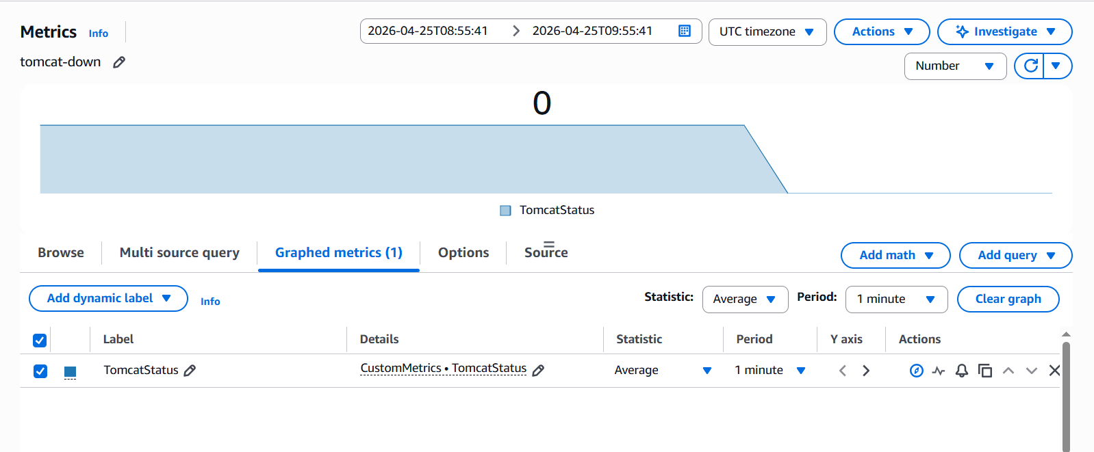
We received mail like your tomcat service is down
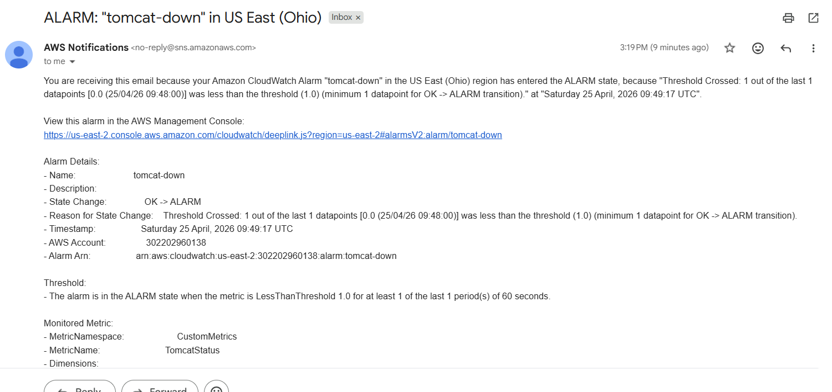

I have started the service and see the metrics shows 1 that is your service is up and running
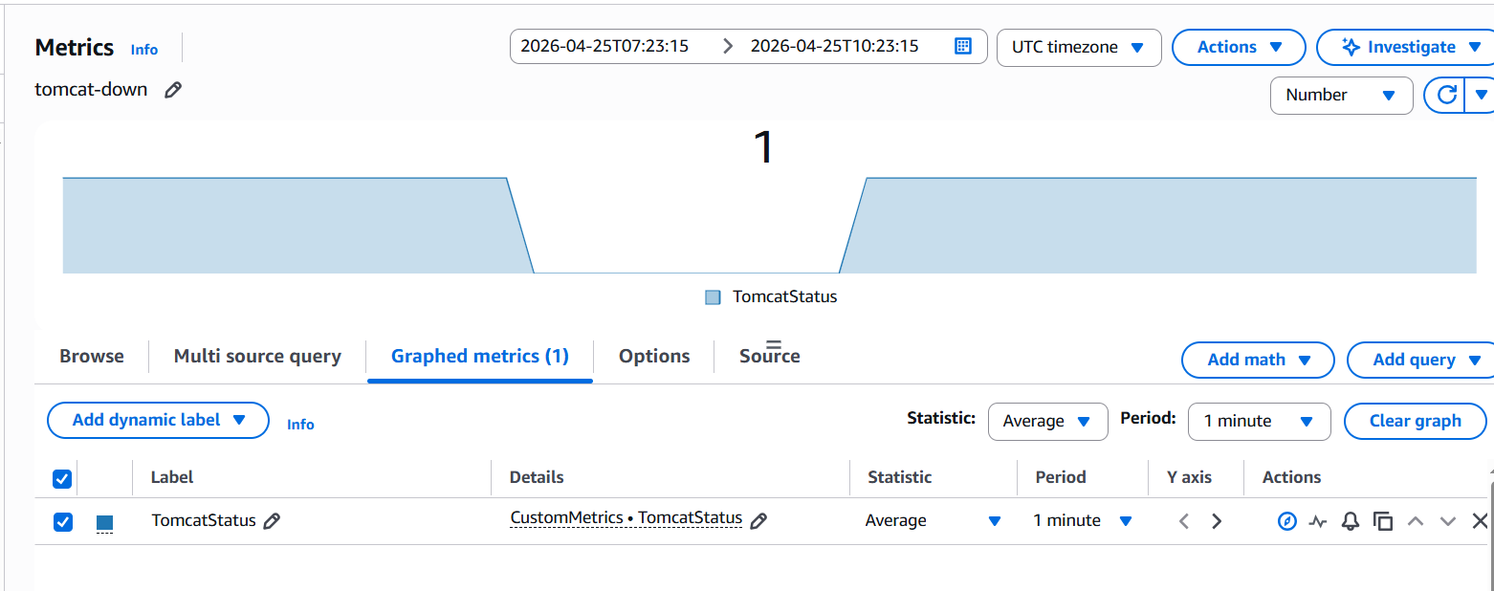
- Create a Dashboard and monitor the Nginx service to send the alert if Nginx is not running.
Create Nginx Status Script (on EC2)
Output:
- 1 → Nginx running
- 0 → Nginx stopped

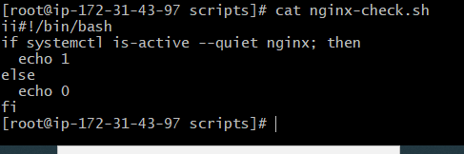

Send Metric to CloudWatch
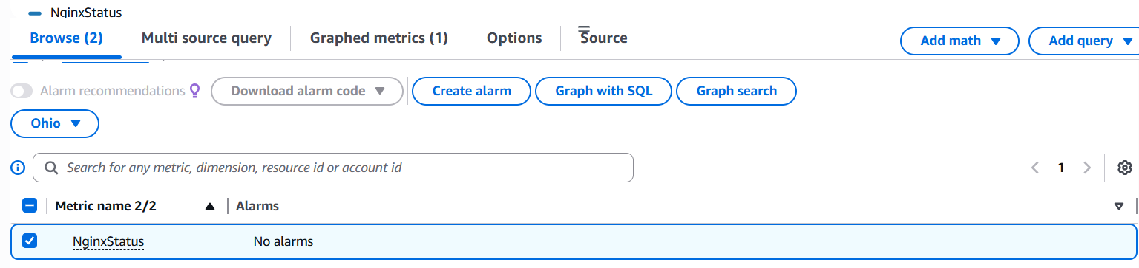
Create alarm
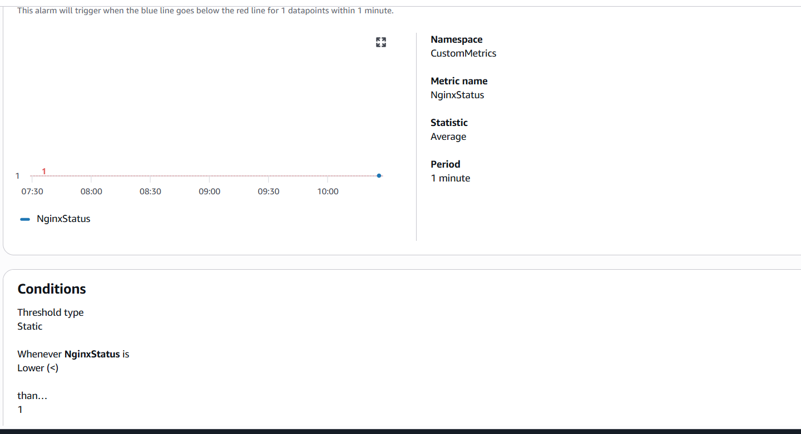
Created an alarm now it is in OK stage
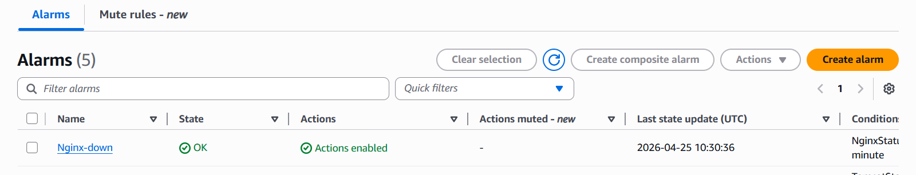

Stop the service , now it is in alarm stage
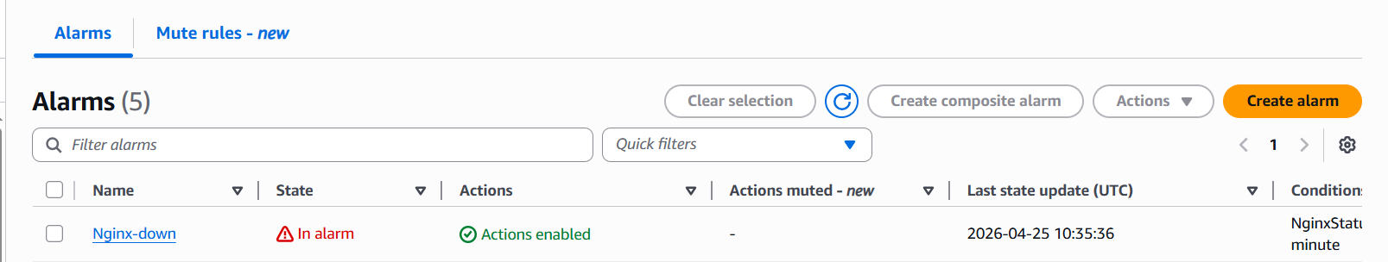

We will the mail


